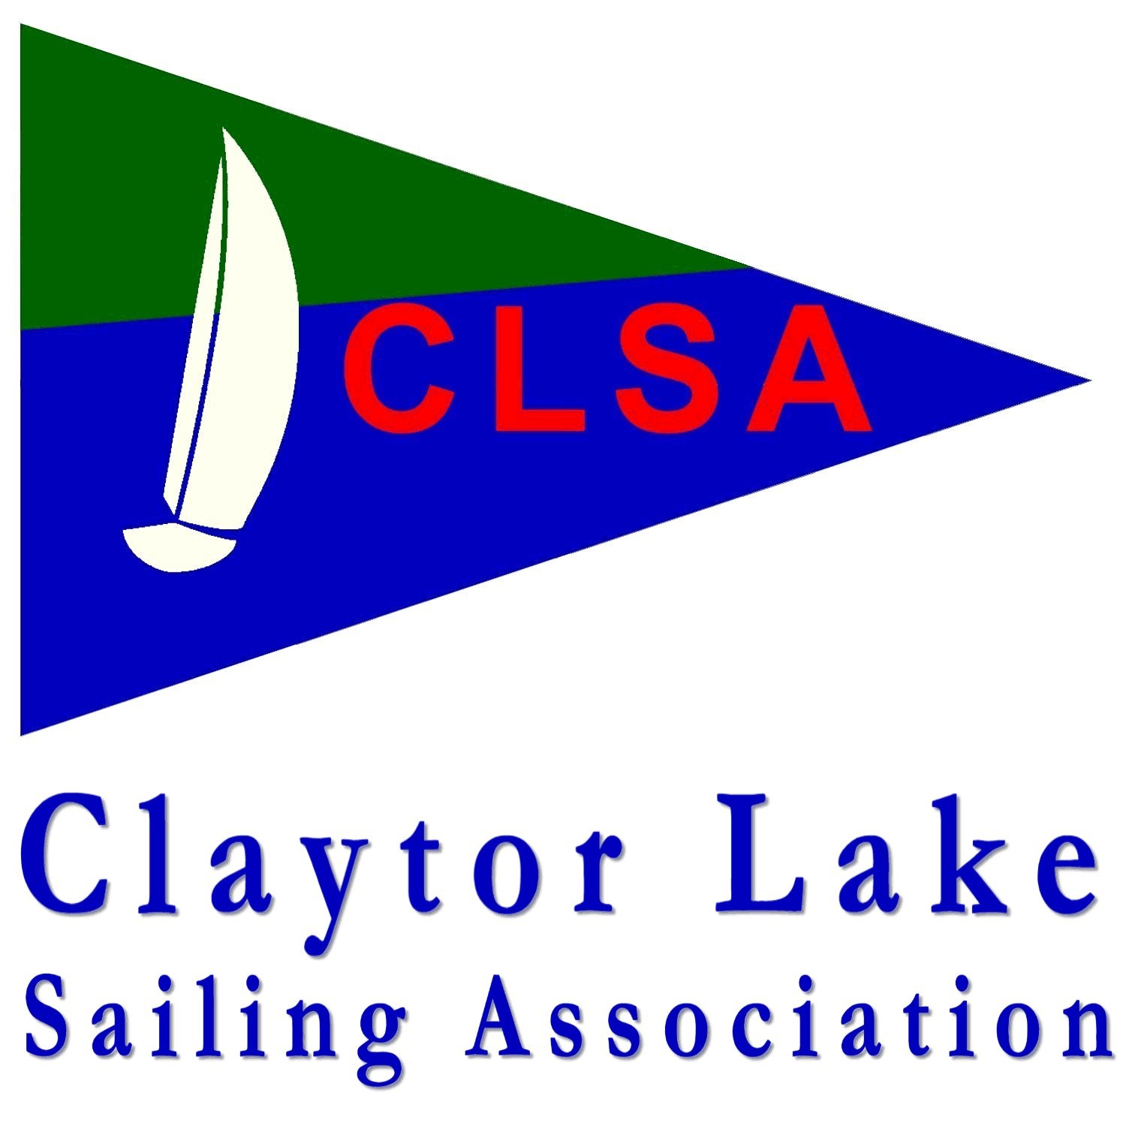
Claytor Lake Sailing Association
Racing Season 2018
Claytor Lake, VA

SAILING INSTRUCTIONS
1. RULES
a. All racing will be governed by the rules as defined in The Racing Rules of Sailing (RRS).
b. The USSailing Portsmouth Yardstick handicap system will be applied to all classes.
c. Prior to the preparatory signal of the first race of each day, each boat is required to check in with the Race Committee (RC) boat at the start line, giving her boat name, and must receive acknowledgement.
2. ELIGIBILITY & ENTRIES
a. Paid members of CLSA are eligible to race and be scored. Other participating boats will not be scored.
b. Competitors may enter by delivering completed waiver forms for the skipper and all crew members prior to racing. Waivers must be updated every season. Waivers are available at www.sailclaytor.org, are attached, and may be handed to the RC in person or emailed to CLSARacing@gmail.com (preferred).
c. All boats who race must volunteer for at least one Race Committee duty via online sign-up. Dates are distributed on a first-come, first-serve basis. Boats who do not volunteer will not be scored.
d. It is the responsibility of each owner/skipper expecting to race to contact the RC prior to their first race to ensure that the appropriate handicap is applied. Races will be scored as quickly as possible, and in the absence of specific boat model information, the RC will utilize the base USSailing D-PN as listed at http://www.ussailing.org/racing/offshore-big-boats/portsmouth-yardstick/current-tables/
3. NOTICES TO COMPETITORS
a. Notices to competitors posted prior to racing will be sent to the CLSA email Google Group: SailClaytor.
b. Shortly prior to, and during, races, the Race Committee will monitor VHF channel 68. Courses, changes, and other information will be broadcast over VHF Channel 68.
4. SCHEDULE
a. The schedule of races will be emailed to the SailClaytor email group and posted on the CLSA website (sailclaytor.org). Races run every other week, typically on Saturday afternoons, from May 7 to October 22, with 4 race days in each of the Spring and Fall series.
b. The warning signal for the first race will 2:00pm each race day, unless otherwise indicated ahead of time. Subsequent races on each day will be held, conditions permitting, as soon as possible after the end (time of last boat’s finish) of the previous race.
c. 8 race days are scheduled, with 6 in the Spring Series and 4 in the Fall Series.
5. RACING AREA
a. The racing area will be in the main body of water of the northern area of Claytor Lake adjacent to Claytor Lake State Park.
6. COURSES and MARKS
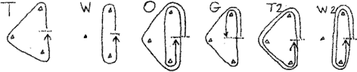
a. The courses shall be as follows:

b. The only exception to listed courses shall be the course for the Cruising Race, which shall be at the discretion of the RC.
c. All marks shall be left to Port.
d. Unless otherwise specified by the Race Committee before the Preparatory Signal, the start/finish line is required, which means that competitors must sail through the start/finish line on each lap of a race.
e. The course will be announced by RC over VHF 68 and verbal hail
f. All marks will be large, inflatable marks; yellow or orange tetrahedrons or cylinders.
7. STARTING AND FINISHING LINES; STARTING SYSTEM
a. The starting and finishing lines will be between an inflatable orange cylinder mark and the tallest mast of the committee boat (if boat has no mast, line will be to the Class Flag flagpole).
b. The starting system used will be the standard USSailing 5 minute start sequence as detailed in RRS Rule 26 and described below. Visual Signals (flags) may be optional per Race Committee discretion.
Minutes before starting signal | Visual Signal (optional) | Sound Signal | What Does it Mean?
5 min 30 sec  (courtesy only - not an official USSailing sequence time) | n/a | Multiple horns | Courtesy: Get ready for Warning
5 | Class Flag (CLSA Burgee) raised | One horn | Warning Signal
4 | P Flag raised | One horn | Preparatory Signal
1 | P Flag lowered | One long horn | One minute
0 | Burgee lowered | One long horn | Starting Signal - Go!
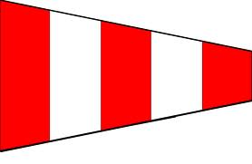
c. In case of a postponement, the RC will sound 2 horns and raise the AP flag (optional), and hail racers over the VHF. When the AP flag is lowered, 1 horn sounds, and that marks 1 minute until the standard 5 min race sequence starts (RRS 27.3)
8. SCORING
a. The High-Point Percentage Scoring System will be utilized as described at: http://www.ussailing.org/wp-content/uploads/DARoot/Race%20Admin/Racing%20Rules/Documents/Scoring%20a%20Long%20Series.pdf
b. A minimum of 8 races are scheduled. A minimum of at least one completed race will constitute a series. If a boat completes at least 8 races throughout the Overall season, then her 2 worst scores shall be excluded from her overall Claytor Cup series score. No score exclusions will be given for Spring or Fall season scores.
c. To qualify for inclusion in series scores, boats shall compete in (i.e., come to the starting area for) at least 2 of the race days for Spring series scores, 2 race days for Fall series score, or at least 4 of the race days throughout the entire season for Claytor Cup series scores.
d. Boats will be scored based on the number of boats competing, with the first place boat gaining a number of points equal to the number of competing boats, and each place thereafter subtracting 1 point. Boats with a DNS, DNF, DSQ or OCS (see RRS A11) will receive a 0. Boats that do not compete (DNC) will not be scored.
e. Race ties will be handled using RRS rule A7. Series ties will be broken using RRS rule A8.1
f. Boats will receive placement scores for each of the 2 series as well as an Overall series score.

